**PES University, Bangalore**

(Established under Karnataka Act No. 16 of 2013)

**Department of Computer Science and Engineering**

**UE21CS352A : OBJECT ORIENTED ANALYSIS AND DESIGN USING JAVA**

**Mini Project**

**Title – Online Coding Evaluation Platform**

**Use Case and Class Diagram**

|  |  |  |
| --- | --- | --- |
| **Sl No.** | **Name of the Student** | **SRN** |
| 1. | Abhiraj | PES1UG21CS022 |
| 2. | Advay Agrawal | PES1UG21CS049 |
| 3. | Akshay Anand | PES1UG21CS064 |
| 4. | Monisha S | PES2UG22CS809 |

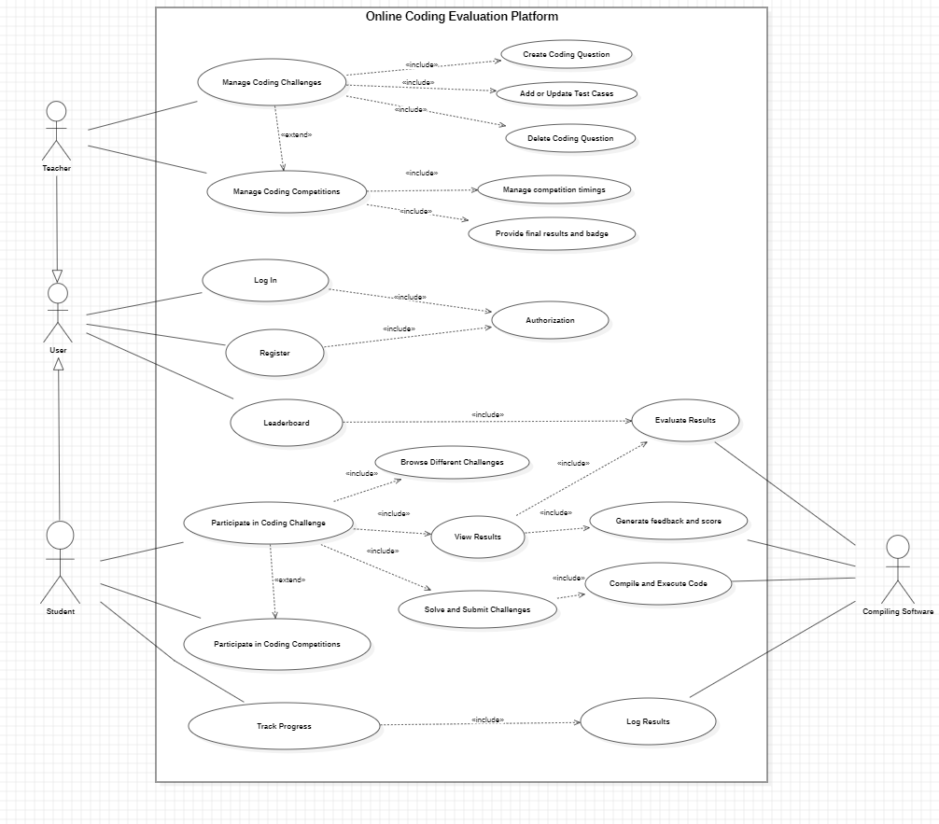**Use Case Diagram**

**Class Diagram**

